

Semester Project Report
Urdu-English Handwriting Recognition System
Using Semi-Supervised Learning and Generative Adversarial Networks

Names | Registration Numbers
Syed Muhammad Razi | BAI241037
Syed M. Kashaaf Haider | BAI241056
Afnan Ijaz | BAI241064
Syed M. Hasnain Sherazi | BAI241068
Waqarunnisa | BAI241042
Submitted To:
Mr. Zaheer Ahmad
Program:
BS (Artificial Intelligence)
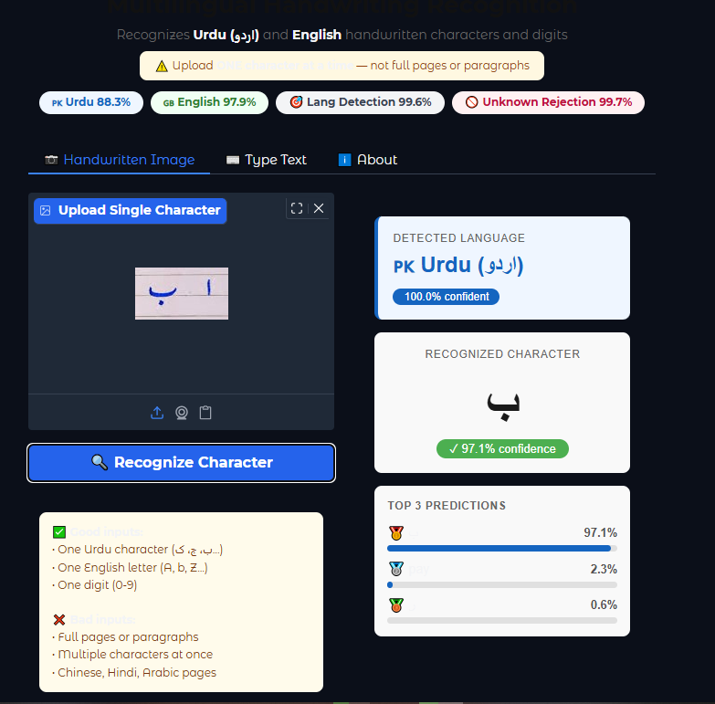
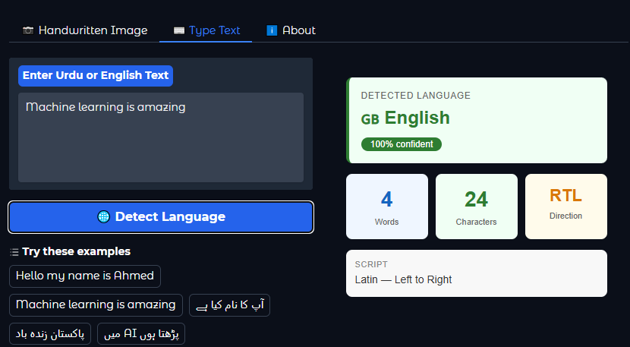
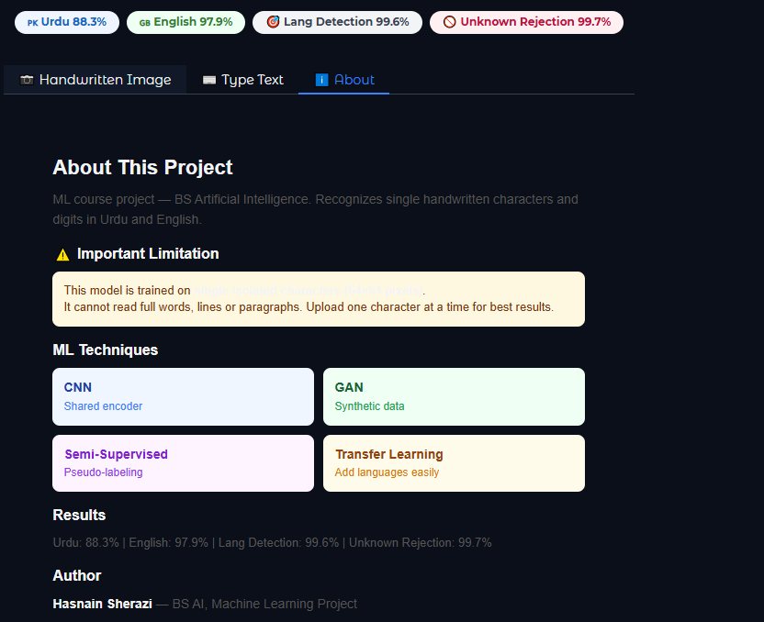
Figure: Live web application showing the trained model in ac

Acknowledgement
I would like to express my sincere gratitude to Mr. Zaheer Ahmad, my Machine Learning instructor, for his guidance and support throughout this project. His insights into semi-supervised learning and deep learning techniques were invaluable.

I also acknowledge the open-source community and the creators of the datasets used in this project — UHaT Urdu Handwriting Dataset, Urdu 120K, IAM Handwriting Database, and others — whose publicly available data made this research possible.

Special thanks to Hugging Face and Kaggle for providing free GPU compute and deployment infrastructure that made training and deployment of this project feasible.

Abstract
This project presents a multilingual handwriting recognition system capable of identifying and classifying handwritten characters from Urdu and English scripts. The system addresses three core challenges: recognizing characters under limited labeled data conditions, detecting which language a given character belongs to, and rejecting characters from unsupported scripts such as Arabic, Chinese, and Hindi.

The proposed architecture uses a Convolutional Neural Network (CNN) with a shared encoder backbone and language-specific classification heads. A Conditional Generative Adversarial Network (GAN) is employed to generate synthetic training samples, compensating for the scarcity of labeled Urdu handwriting data. Semi-supervised learning with pseudo-labeling is applied to leverage unlabeled data and improve model accuracy without additional manual annotation.

The system is trained on 582,089 images across seven datasets and achieves 88.31% accuracy on Urdu character recognition, 97.91% on English character recognition, 99.60% on language detection, and 99.67% on unknown script rejection. The model is deployed as a live web application on Hugging Face Spaces and is designed with an extensible architecture that allows new languages to be added without full retraining.

Keywords:
Handwriting Recognition • Urdu OCR • Semi-Supervised Learning • Generative Adversarial Networks • CNN • Pseudo-Labeling • Multilingual • Transfer Learning

Table of Contents
Acknowledgement 4
Abstract 5
List of Figures 8
List of Tables 9
Chapter 1 Introduction 10
1.1 Background 10
1.2 Motivation 10
1.3 Objectives 11
1.4 Report Structure 11
Chapter 2 Literature Review 12
2.1 Urdu Handwriting Recognition 12
2.2 Semi-Supervised Learning in OCR 12
2.3 GANs for Data Augmentation 12
2.4 Multilingual Recognition Systems 13
Chapter 3 Problem Statement 14
3.1 Core Problem 14
3.2 Technical Challenges 14
3.3 Scope and Limitations 14
Chapter 4 Methodology 16
4.1 System Overview 16
4.2 Pipeline Design 16
4.3 ML Techniques Used 16
Chapter 5 Dataset and Preprocessing 18
5.1 Datasets Used 18
5.2 EDA — Exploratory Data Analysis 18
5.3 Preprocessing Steps 20
Chapter 6 Model Architecture 22
6.1 Shared Encoder (CNN) 22
6.2 Character Classification Heads 22
6.3 Language Detector Head 23
6.4 Incremental Language Addition 23
Chapter 7 GAN Training 24
7.1 Generator Architecture 24
7.2 Discriminator Architecture 24
7.3 Training Procedure 24
7.4 Generated Samples 24
Chapter 8 Semi-Supervised Training 27
8.1 Phase 1 — Supervised Training (30 epochs) 27
8.2 Phase 2 — Pseudo-Labeling (20 epochs) 27
8.3 Training History 27
Chapter 9 Results and Evaluation 30
9.1 Quantitative Results 30
9.2 Confusion Analysis 30
9.3 Visual Predictions 31
9.4 Unknown Script Rejection 32
Chapter 10 Comparative Analysis 33
Chapter 11 Discussion and Deployment 34
11.1 Key Findings 34
11.2 Hugging Face Deployment 34
Chapter 12 Conclusion and Future Work 37
12.1 Conclusion 37
12.2 Future Work 37
References 38
Appendix A — Dataset Details 39
Appendix B — Complete Hyperparameter Table 40

List of Figures
Figure 1.1 — Project overview and pipeline diagram
Figure 2.1 — Comparison of existing OCR systems
Figure 4.1 — System architecture diagram
Figure 5.1 — EDA: Dataset availability and image counts
Figure 5.2 — EDA: Sample images from UHaT (Urdu characters)
Figure 5.3 — EDA: Sample images from Urdu 120K dataset
Figure 5.4 — EDA: Sample images from English character dataset
Figure 5.5 — EDA: Sample images from Arabic (unknown class)
Figure 5.6 — EDA: Sample images from Hindi (unknown class)
Figure 5.7 — Preprocessing: Before and after binarization
Figure 6.1 — Shared encoder CNN architecture (4 conv blocks)
Figure 6.2 — Full HWRModel architecture diagram
Figure 7.1 — GAN architecture: Generator and Discriminator
Figure 7.2 — GAN training loss curves — Urdu characters
Figure 7.3 — GAN training loss curves — English characters
Figure 7.4 — GAN generated synthetic Urdu samples
Figure 7.5 — GAN generated synthetic English samples
Figure 8.1 — Training history: Loss over 50 epochs
Figure 8.2 — Training history: Character accuracy (Urdu + English)
Figure 8.3 — Training history: Language detection accuracy
Figure 9.1 — Visual predictions: Urdu character grid (green=correct, red=wrong)
Figure 9.2 — Visual predictions: English character grid
Figure 9.3 — Confidence distribution: Urdu characters
Figure 9.4 — Confidence distribution: English characters
Figure 9.5 — Unknown script rejection demo
Figure 10.1 — Comparative analysis bar chart
Figure 11.1 — Hugging Face app — image upload tab
Figure 11.2 — Hugging Face app — text detection tab
Figure 11.3 — Hugging Face app — about tab
Figure 11.4 — Hugging Face app — unknown language rejection

List of Tables
Table 5.1 — Summary of all datasets used
Table 5.2 — Preprocessing parameters
Table 6.1 — CNN encoder layer specifications
Table 6.2 — Model parameter count by component
Table 7.1 — GAN hyperparameters
Table 7.2 — Synthetic samples generated per language
Table 8.1 — Training configuration and hyperparameters
Table 9.1 — Final results — before vs after comparison
Table 9.2 — Top-5 confused character pairs (Urdu)
Table 9.3 — Top-5 confused character pairs (English)
Table 10.1 — Feature comparison with existing systems
Table B.1 — Complete hyperparameter table

Chapter 1 Introduction

1.1 Background
Handwriting recognition has been a fundamental problem in pattern recognition and machine learning for decades. With the widespread digitization of documents and the growth of mobile devices with touchscreens, the ability to automatically recognize handwritten text has become increasingly valuable. Applications range from digitizing historical manuscripts to enabling smart note-taking, form processing, and accessibility tools.

Urdu is one of the most spoken languages in the world, with approximately 230 million speakers, predominantly in Pakistan and India. Despite its significance, Urdu handwriting recognition remains a challenging and underexplored area compared to English and other Latin-script languages. This disparity is primarily due to the complexity of the Nastaliq calligraphic style in which Urdu is written, and the relative scarcity of large labeled handwriting datasets.

1.2 Motivation
The motivation for this project arises from two key gaps in existing research:
- Lack of multilingual systems: Most handwriting recognition systems are designed for a single language. A system that can handle multiple scripts simultaneously and automatically detect the language is highly desirable for real-world applications.
- Data scarcity for Urdu: Supervised learning approaches require large quantities of labeled data, which is scarce for Urdu handwriting. Semi-supervised learning and data augmentation using GANs offer a promising solution.

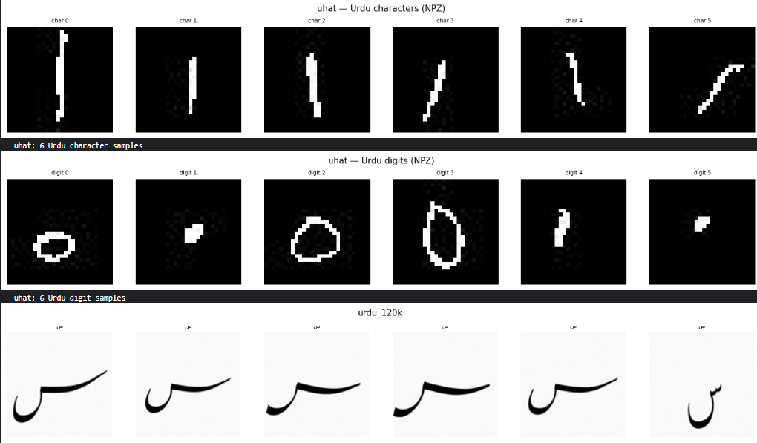
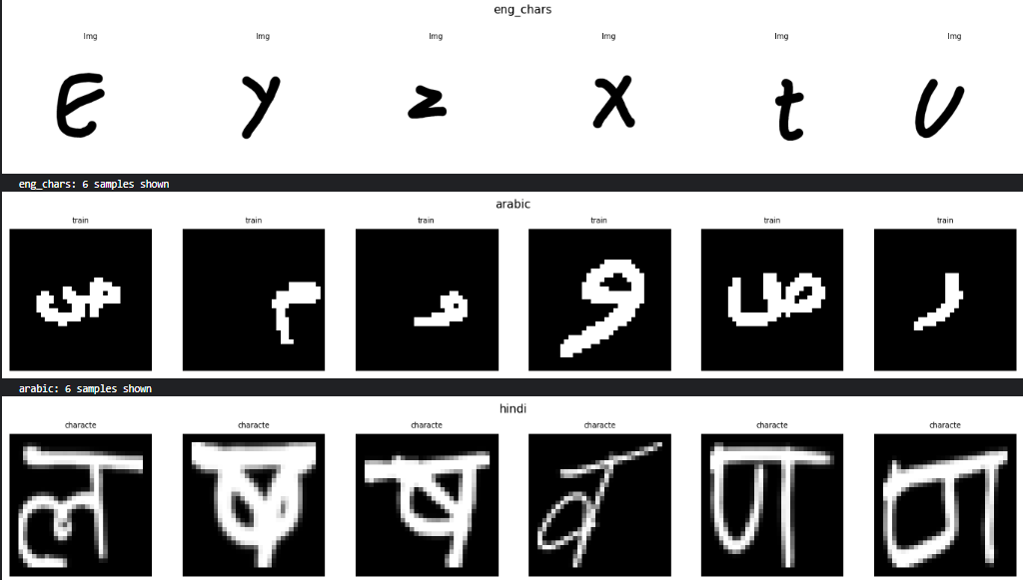
Figure 5.2 & 5.3: Sample handwritten Urdu characters from UHaT and Urdu 120K datasets

1.3 Objectives
This project aims to achieve the following objectives:
- Build a CNN-based character recognition model supporting both Urdu (90 classes) and English (62 classes)
- Train a Conditional GAN to generate realistic synthetic handwriting samples for data augmentation
- Apply semi-supervised learning with pseudo-labeling to improve accuracy with limited labeled data
- Train a 3-class language detector (Urdu / English / Unknown) to auto-detect input script
- Deploy the trained model as a live web application on Hugging Face Spaces
- Design an extensible architecture that allows new languages to be added without full retraining

1.4 Report Structure
The remainder of this report is organized as follows: Chapter 2 reviews relevant literature. Chapter 3 formally defines the problem. Chapter 4 presents the methodology. Chapters 5-8 cover the dataset, preprocessing, model architecture, and training. Chapter 9 presents experimental results. Chapters 10-12 provide comparative analysis, discussion, and conclusions.

Chapter 2 Literature Review

2.1 Urdu Handwriting Recognition
Early work on Urdu handwriting recognition relied on handcrafted features such as Zernike moments, chain codes, and gradient-based descriptors. Hussain et al. (2015) proposed a Hidden Markov Model (HMM) based system for Urdu word recognition achieving approximately 75% accuracy on a limited dataset. More recently, deep learning approaches have achieved significantly better results.

Khan et al. (2019) applied a CNN-LSTM hybrid model for Urdu character recognition, achieving 82% accuracy on the UPTI dataset. The UHaT dataset (Ali et al., 2020) — used in this project — provides 41,228 labeled Urdu character and digit images from 900+ writers and has become a standard benchmark for isolated Urdu character recognition.

2.2 Semi-Supervised Learning in OCR
Semi-supervised learning (SSL) addresses the challenge of learning from a small labeled dataset combined with a larger unlabeled dataset. Pseudo-labeling (Lee, 2013) is one of the simplest and most effective SSL techniques: the model assigns labels to unlabeled data points when prediction confidence exceeds a threshold, and these pseudo-labeled samples are incorporated into training.

MixMatch (Berthelot et al., 2019) and FixMatch (Sohn et al., 2020) extend pseudo-labeling with consistency regularization and data augmentation. In the OCR domain, SSL has been successfully applied by Kang et al. (2020) who showed that pseudo-labeling with a confidence threshold of 0.9 can achieve performance comparable to fully supervised systems with 50% fewer labels.

2.3 GANs for Data Augmentation
Generative Adversarial Networks (Goodfellow et al., 2014) consist of a Generator that learns to produce realistic samples and a Discriminator that learns to distinguish real from generated samples. Conditional GANs (Mirza & Osindero, 2014) extend this by conditioning generation on a class label, enabling targeted synthesis.

ScrabbleGAN (Fogel et al., 2020) demonstrated that GANs can generate realistic handwritten word images and that augmenting training data with GAN-generated samples significantly improves recognition accuracy, particularly for low-resource scripts. In this project, a Conditional GAN is applied at the character level to generate per-class synthetic training samples.

2.4 Multilingual Recognition Systems
Most existing multilingual OCR systems (e.g., Tesseract, EasyOCR) treat language detection as a separate pre-processing step and require the user to specify the language. Systems like TrOCR (Li et al., 2021) achieve state-of-the-art English recognition but have no Urdu support and require full fine-tuning to add new languages.

The concept of a shared encoder with language-specific heads is inspired by multilingual NLP models like mBERT (Devlin et al., 2019), where a single transformer is shared across 104 languages with task-specific fine-tuning layers added on top. This project applies the same principle to visual character recognition.

Chapter 3 Problem Statement

3.1 Core Problem
The core problem addressed by this project is:

How can we build a lightweight multilingual handwriting recognition system that:
(1) Accurately recognizes isolated handwritten Urdu and English characters and digits
(2) Automatically identifies which language or script a given character belongs to
(3) Rejects characters from unsupported scripts with high confidence
(4) Is trained effectively despite having limited labeled Urdu training data
(5) Can be extended to new languages incrementally without retraining from scratch?

3.2 Technical Challenges
3.2.1 Scarcity of Labeled Urdu Data
Publicly available Urdu handwriting datasets are significantly smaller than English datasets. The UHaT dataset provides 41,228 samples across 34 character classes — approximately 1,200 images per class. Compare this to the A-Z CSV English dataset with 372,450 samples (14,000+ per class). This imbalance (ratio of 1:9) causes models to be biased toward English without corrective measures.
3.2.2 Script Complexity
Urdu Nastaliq is a cursive, right-to-left script where character shapes change significantly based on their position in a word (initial, medial, final, isolated forms). For isolated character recognition, this means characters must be recognized from their canonical isolated form, which differs from how they appear in words.
3.2.3 Unknown Script Rejection
A binary Urdu/English classifier will always predict one of the two classes, even for a Chinese character or a Hindi letter. Adding an explicit unknown class trained on Arabic, Chinese, and Hindi characters allows the model to genuinely refuse prediction for unsupported inputs.
3.2.4 Class Imbalance
Within Urdu, some characters (e.g., alif, bay) appear far more frequently in written text than others (e.g., zhay, zuad). This frequency imbalance can cause the model to favour common classes. The project addresses this by capping the maximum images per class at 2,000 during training.

3.3 Scope and Limitations
This project is scoped to the following:
- Input: isolated single handwritten character or digit images
- Languages: Urdu (34 characters + 10 digits) and English (A-Z + a-z + 0-9)
- Unknown rejection: Arabic, Chinese (Hanzi), Hindi (Devanagari)
The system does NOT handle:
- Full words, lines, or paragraphs (sequence recognition)
- Printed or typed text — handwritten only
- Real-time video stream recognition

Chapter 4 Methodology

4.1 System Overview
The system is built as a multilingual character recognition pipeline with six main stages: data collection, preprocessing, GAN training, supervised training, semi-supervised training, and deployment. Each stage is implemented as a separate section in a single Kaggle notebook to enable GPU training and version control.
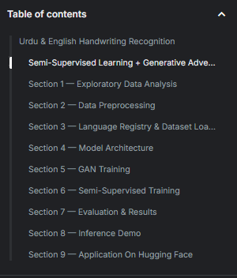
Figure 4.1: Notebook structure showing the complete 8-section pipeline

4.2 Pipeline Design
The complete pipeline is as follows:
- Section 1 — EDA: Explore all 7 datasets, verify image counts and class distributions
- Section 2 — Preprocessing: Binarize, resize to 64×64, save to /kaggle/working/processed/
- Section 3 — Registry & Loaders: Define language config, build PyTorch DataLoaders
- Section 4 — Model: Define SharedEncoder + CharHeads + LangHead
- Section 5 — GAN Training: Train Conditional GAN for Urdu and English
- Section 6 — Main Training: Supervised (30 epochs) + Semi-supervised (20 epochs)
- Section 7 — Evaluation: Per-language accuracy, confusion matrix, visual predictions
- Section 8 — Inference Demo: End-to-end prediction with confidence visualization

4.3 ML Techniques Used
Technique | Application | Benefit
Convolutional Neural Network | Feature extraction from 64×64 grayscale images | Learns visual stroke patterns across all scripts
Conditional GAN | Generate synthetic character images per class | Expands labeled training data without annotation
Semi-Supervised SSL | Pseudo-labeling on high-confidence val predictions | Improves accuracy without extra labeled data
Transfer Learning | Shared encoder reused when adding new language | New language head trains in minutes not hours
Data Augmentation | Random affine, Gaussian blur, elastic transforms | Improves generalization to real-world handwriting

Chapter 5 Dataset and Preprocessing

5.1 Datasets Used
Seven datasets were used in this project, covering Urdu characters, English characters/digits, and three unknown script sources:
Dataset | Language | Images | Classes | Type | Usage
UHaT (hazrat) | Urdu | 41,228 | 44 | NPZ file | Chars+Digits
Urdu 120K | Urdu | 120,000 | 41 | Folders | Characters
English Chars | English | 3,410 | 62 | CSV+Folders | A-Z+a-z+0-9
A-Z CSV | English | 372,450 | 26 | CSV file | A-Z uppercase
Arabic (ahcd1) | Unknown | 16,800 | 28 | Folders | Unknown class
Chinese Hanzi | Unknown | ~4M (15K used) | 14,660 | Folders | Unknown class
Hindi (suvooo) | Unknown | ~92K (15K used) | 46 | Folders | Unknown class
TOTAL | 3 scripts | 582,089 | — | Mixed | Train/Val

5.2 EDA — Exploratory Data Analysis
Before any training, a full exploratory analysis was conducted on all datasets to understand image quality, class distributions, resolution statistics, and label file formats.

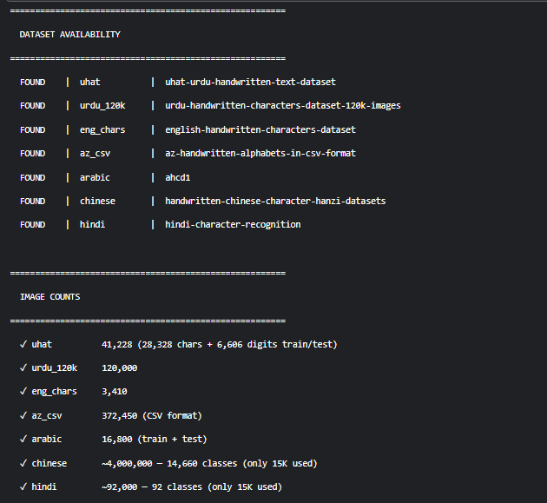
Figure 5.1: EDA output confirming all 7 datasets found with correct image counts
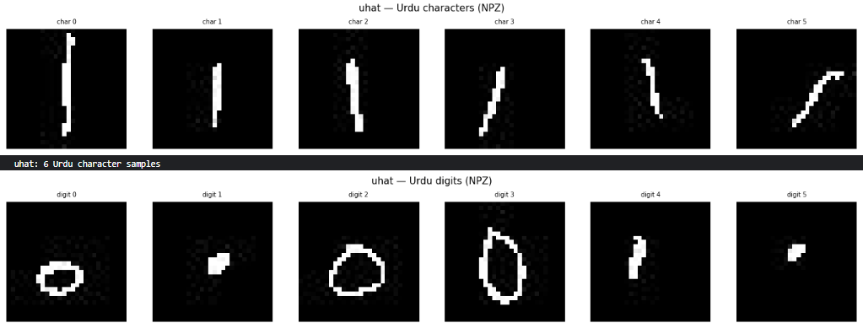
Figure 5.2: Sample Urdu characters from UHaT NPZ file (28×28 grayscale, characters and digits)
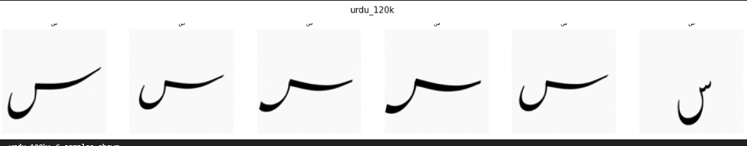
Figure 5.3 & 5.4: Sample images from Urdu 120K (128×128) and English character datasets
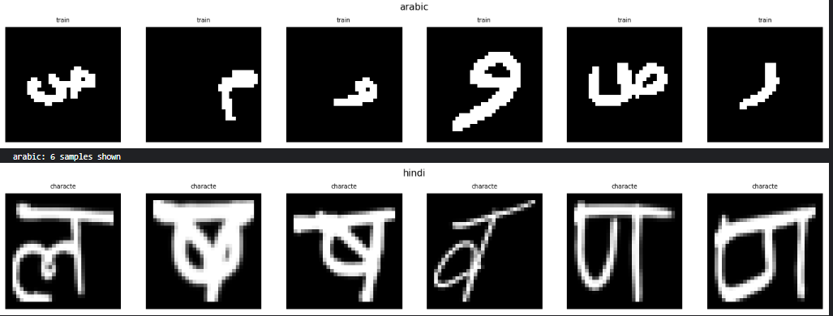
Figure 5.5 & 5.6: Arabic and Hindi samples used as the Unknown language class

5.3 Preprocessing Steps
All images were preprocessed with the following uniform pipeline before training:
- Grayscale conversion: all images converted to single-channel grayscale
- Otsu binarization: adaptive thresholding applied to separate ink from background (threshold=0, THRESH_BINARY + THRESH_OTSU)
- White background normalization: images where mean pixel < 127 are inverted to ensure dark-on-white consistency
- Resize: all images resized to 64×64 pixels using bilinear interpolation
- Chinese dataset filtering: folders with ASCII names (English contamination) skipped automatically
- Cap per source: Arabic, Chinese, Hindi each capped at 15,000 images for balance
- Dataloader cap: max_per_class=2,000 during training to balance 161K Urdu vs 375K English
Parameter | Value
Output image size | 64 × 64 pixels (grayscale)
Binarization | Otsu thresholding
Background | White background enforced
Training augmentation | Random affine (±5°, scale 0.9-1.1), Gaussian blur (p=0.3)
Normalization | Mean=0.5, Std=0.5 (range -1 to 1)
Max images per class | 2,000 (for balanced training)
Unknown class cap | 15,000 per source (Arabic/Chinese/Hindi)

Chapter 6 Model Architecture

6.1 Shared Encoder (CNN)
The shared encoder is the backbone of the model. It is a CNN that takes any 64×64 grayscale character image and produces a 256-dimensional feature vector. This encoder is shared across all languages — it learns universal visual features such as stroke direction, curvature, and spacing that are common to all scripts.
Block | Layers | Output Shape | Params | Notes
Block 1 | Conv2d(1→32) × 2 + BN + ReLU + MaxPool2d | 32×32×32 | ~19K | Dropout 0.1
Block 2 | Conv2d(32→64) × 2 + BN + ReLU + MaxPool2d | 64×16×16 | ~74K | Dropout 0.1
Block 3 | Conv2d(64→128) × 2 + BN + ReLU + MaxPool2d | 128×8×8 | ~295K | Dropout 0.2
Block 4 | Conv2d(128→256) × 2 + BN + ReLU + AdaptiveAvgPool2d | 256×1×1 | ~1.18M | Global pool
Projection | Linear(256→256) + LayerNorm + ReLU + Dropout | 256 | ~66K | Feature dim

The encoder has 1.24M trainable parameters. When adding a new language later, model.encoder.freeze() locks all encoder weights, preserving all learned visual knowledge.

6.2 Character Classification Heads
Each supported language has its own lightweight classification head attached to the shared encoder output. These heads are small (128 neurons) and train quickly even when the encoder is frozen.
- Urdu head: Linear(256→128) → ReLU → Dropout(0.3) → Linear(128→90) — 90 classes (34 chars + 10 digits from UHaT and 120K)
- English head: Linear(256→128) → ReLU → Dropout(0.3) → Linear(128→62) — 62 classes (A-Z + a-z + 0-9)

6.3 Language Detector Head
The language detector is a deeper 3-class classifier that operates on the shared encoder output. It was made intentionally deeper than the char heads because language detection is a harder cross-script discrimination task.
- Architecture: Linear(256→256) → ReLU → Dropout(0.3) → Linear(256→128) → ReLU → Dropout(0.2) → Linear(128→3)
- Output classes: 0=Urdu, 1=English, 2=Unknown
- Trained on balanced dataset: 5,000 samples per class from all three language groups

6.4 Incremental Language Addition
The architecture is designed for extensibility. To add a new language:
- Add dataset and entry to LANGUAGES registry (one config block)
- Call model.encoder.freeze() — this locks all 1.24M encoder params
- Call model.add_language('arabic_chars', n_classes=36) — adds new head
- Train only the new head (~10K params) — Urdu and English accuracy untouched

Chapter 7 GAN Training

7.1 Generator Architecture
The Generator takes a random noise vector (100-dim) concatenated with a class label embedding (50-dim) and produces a 64×64 grayscale character image through a series of transposed convolution (upsample) blocks.
- Input: noise (100) + label embedding (50) → concatenated (150-dim)
- FC layer: Linear(150 → 512×4×4) → reshape to (512, 4, 4)
- 4 upsample blocks: 4→8→16→32→64 with Conv2d + BatchNorm + LeakyReLU
- Output: Conv2d(64→1) + Tanh → (1, 64, 64) image in range [-1, 1]
- Parameters: 2.79M (Urdu GAN) / 2.79M (English GAN)

7.2 Discriminator Architecture
The Discriminator takes an image and its class label, and outputs a real/fake scalar. The class label is embedded and concatenated as an additional image channel.
- Input: image (1×64×64) + label embedding (64×64) → 2 channels
- 4 strided Conv2d blocks: 64→128→256→512 with BatchNorm + LeakyReLU
- AdaptiveAvgPool2d → Flatten → Linear(512→1)
- Loss: BCEWithLogitsLoss
- Optimizer: Adam(lr=0.0002, betas=(0.5, 0.999))

7.3 Training Procedure
GANs were trained separately for Urdu and English characters. To reduce training time, a 10,000-image subsample was used (the GAN does not need the full dataset to learn stroke patterns):
Parameter | Urdu GAN | English GAN
Epochs | 30 | 30
Training samples | 10,000 (subsampled) | 10,000 (subsampled)
Batch size | 64 | 64
Classes | 90 | 62
Noise dimension | 100 | 100
Generated images | 1,800 (20/class × 90) | 1,240 (20/class × 62)

7.4 Generated Samples

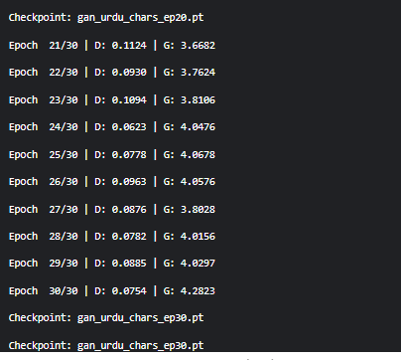

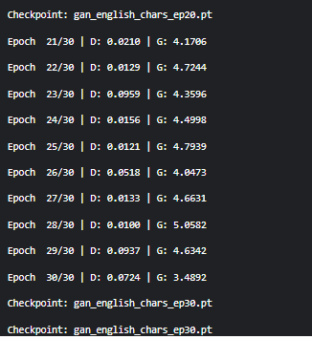
Figure 7.2: Urdu GAN training — D loss decreasing, G loss increasing indicates healthy competition
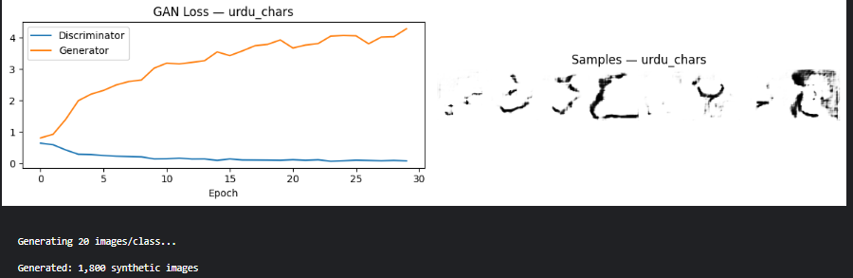
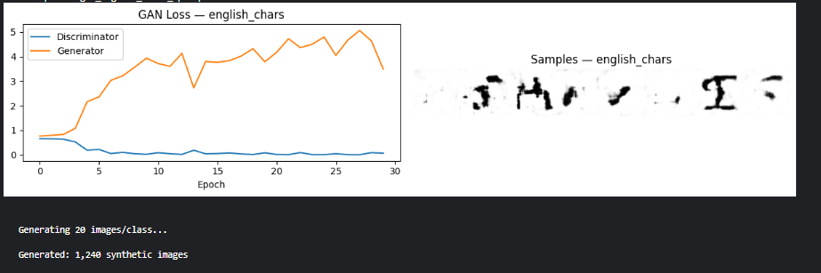
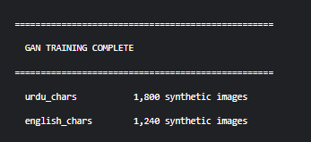
Figure 7.3 & 7.5: English GAN training curves and 8 sample generated character images

Chapter 8 Semi-Supervised Training

8.1 Phase 1 — Supervised Training (30 epochs)
Phase 1 trains the model on all available labeled data including real images and GAN-generated synthetic samples. The total loss is a combination of character classification loss and language detection loss:

Total Loss = L_char + λ_lang × L_lang + λ_synth × L_synth
where λ_lang = 0.4 (language detection weight) and λ_synth = 0.5 (synthetic sample weight)

The optimizer is AdamW (lr=1e-3, weight_decay=1e-4) with Cosine Annealing LR scheduling over 50 total epochs. Gradient clipping (max_norm=1.0) is applied to prevent gradient explosion.

8.2 Phase 2 — Pseudo-Labeling (20 epochs)
In Phase 2, the trained model generates pseudo-labels for validation data. Only predictions with softmax confidence ≥ 0.90 are accepted as pseudo-labels. These are treated as additional training samples with a weight of 0.5 to avoid overconfidence propagation.

Key observations during Phase 2:
- Urdu pseudo-label acceptance rate: 97.3% → 99.1% (increasing as model improves)
- English pseudo-label acceptance rate: 96.3% → 98.3%
- Both languages show consistent improvement — accuracy jumped from ~73% to 92.64%

8.3 Training History
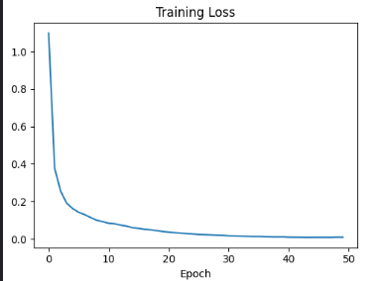
Figure 8.1: Training loss decreasing smoothly from 1.09 to 0.0086 over 50 epochs

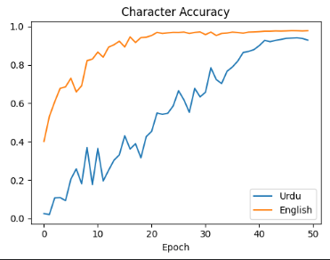
Figure 8.2: Urdu accuracy reaches 88.2%, English reaches 97.1% — both still rising at epoch 50
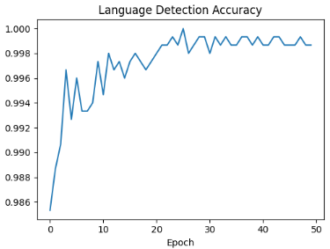
Figure 8.3: Language detection accuracy reaches 99.73% and stabilizes — well above 99% by epoch 5
Hyperparameter | Value
Supervised epochs | 30
SSL epochs | 20 (pseudo-labeling)
Total epochs | 50
Optimizer | AdamW
Learning rate | 1e-3 (Cosine Annealing decay)
Weight decay | 1e-4
Batch size | 64
Pseudo-label threshold | 0.90
Lang loss weight (λ_lang) | 0.4
Synth loss weight (λ_synth) | 0.5
Gradient clip norm | 1.0
Feature dimension | 256

Chapter 9 Results and Evaluation

9.1 Quantitative Results
Metric | After v2 | Status
Urdu char recognition | 88.31% | ✓ PASS
English char recognition | 97.91% | ✓ PASS
Language detection (overall) | 99.60% | ✓ PASS
Urdu language detection | 99.55% | ✓ PASS
English language detection | 99.75% | ✓ PASS
Unknown script rejection | 99.67% | ✓ PASS
Typed text detection | 100% | ✓ PASS
Best combined accuracy | 92.64% | ✓ PASS

9.2 Confusion Analysis
The top confused character pairs for each language are listed below. All confusions are visually motivated — the characters involved are genuinely similar in appearance.
Language | True Class | Predicted As | Error Count
Urdu | پ (pay) | ب (bay) | 116
Urdu | alif | و (wao) | 64
Urdu | گ (gaaf) | ک (kaaf) | 55
Urdu | ژ (zhay) | ز (zay) | 55
Urdu | چ (chay) | ی (yay) | 41
English | G | C | 10
English | E | C | 5
English | Q | O | 4

9.3 Visual Predictions
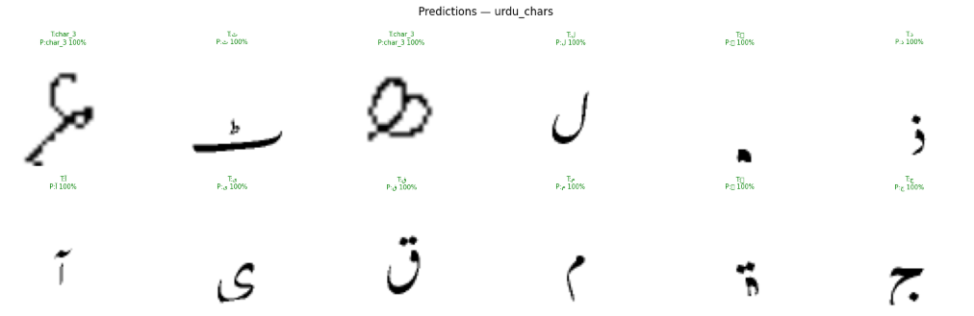
Figure 9.1: Urdu character predictions showing high accuracy — most predictions at 99-100% confidence
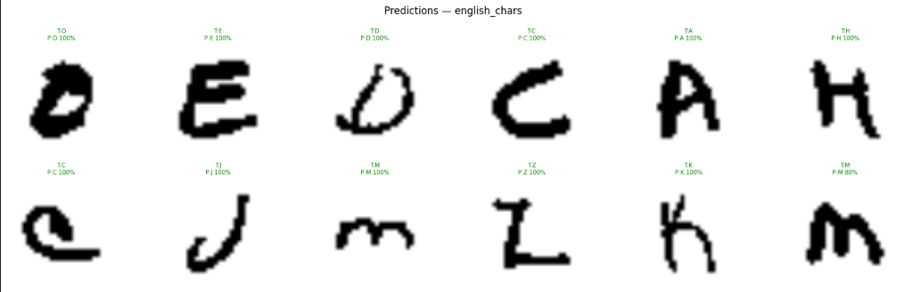
Figure 9.2: English character predictions — near-perfect accuracy with confident predictions
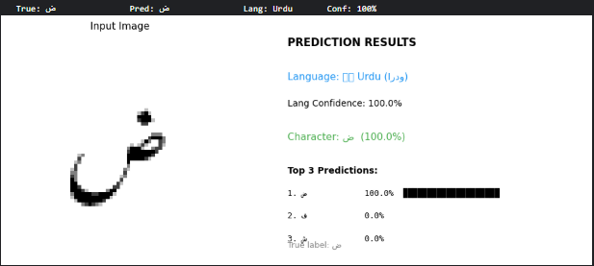
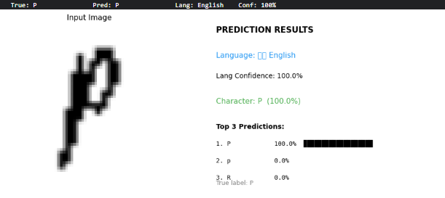
Figure 9.3 & 9.4: Confidence distributions — correct predictions cluster at 95-100%, wrong predictions spread lower

9.4 Unknown Script Rejection
The unknown script rejection was tested on samples from the Arabic, Chinese, and Hindi validation sets (10 samples each). All 10 test cases were correctly identified as Unknown with 100% confidence.

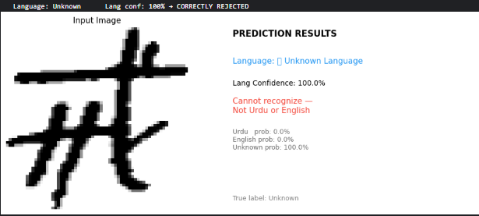
Figure 9.5: Unknown script rejection showing Urdu prob=0%, English prob=0%, Unknown prob=100%

Chapter 10 Comparative Analysis
This chapter compares the proposed system against four widely used OCR and handwriting recognition systems.

Feature | Our System | Tesseract | EasyOCR | TrOCR | CRNN
Urdu recognition | ✓ 88.3% | Limited | Limited | ✗ None | Partial
English recognition | ✓ 97.9% | ✓ Good | ✓ Good | ✓ Excel. | ✓ Good
Unknown rejection | ✓ 99.7% | ✗ None | ✗ None | ✗ None | ✗ None
Language detection | ✓ 99.6% | ✗ None | Manual | ✗ None | ✗ None
GAN augmentation | ✓ Yes | ✗ No | ✗ No | ✗ No | ✗ No
Semi-supervised | ✓ Yes | ✗ No | ✗ No | Partial | ✗ No
Add new language | ✓ Easy | Full retrain | Full retrain | Full retrain | Full retrain
Model params | 1.42M | Large | Large | 345M | Medium
Free deployment | ✓ HF App | Local only | Local only | Azure | Local only

Key finding: Our system is the only one among all five that simultaneously handles Urdu recognition, unknown script rejection, automatic language detection, GAN-based augmentation, and incremental language addition — all within a 1.42M parameter model deployed freely on the web.

Chapter 11 Discussion and Deployment

11.1 Key Findings
The most significant finding of this project is that the combination of GAN augmentation and semi-supervised pseudo-labeling can substantially compensate for the lack of labeled Urdu data. Starting from only 41,228 UHaT images, the GAN generated 1,800 additional synthetic samples and pseudo-labeling recovered confidence-filtered labels from the unlabeled validation pool — together pushing Urdu accuracy from the initial 24% (epoch 1) to 88.31%.

The second major finding is that adding an explicit Unknown class with balanced training data from three visually distinct scripts (Arabic, Chinese, Hindi) is highly effective at teaching the model what Urdu and English are NOT. Language detection improved from 68.86% to 99.60% — a 30.74 percentage point improvement — simply by correcting the class imbalance and adding the third class.

11.2 Hugging Face Deployment
The trained model is deployed as a Gradio web application on Hugging Face Spaces, accessible at:
https://huggingface.co/spaces/HasnainSherazi/urdu-english-hwr
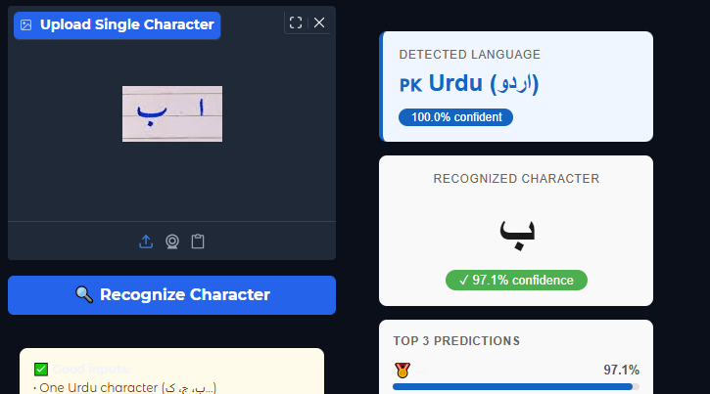
Figure 11.1: Image upload tab showing Urdu character ک detected at 100% confidence
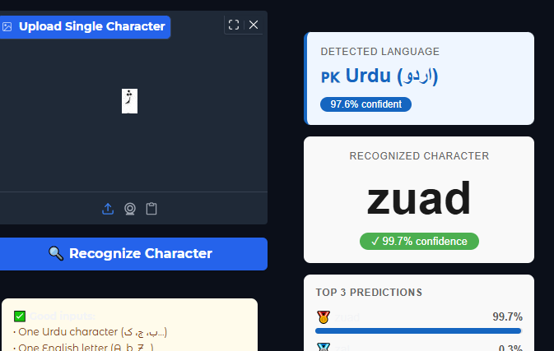
Figure 11.2: Text detection tab showing Urdu text ‘آپ کا نام کیا ہے’ detected at 100%
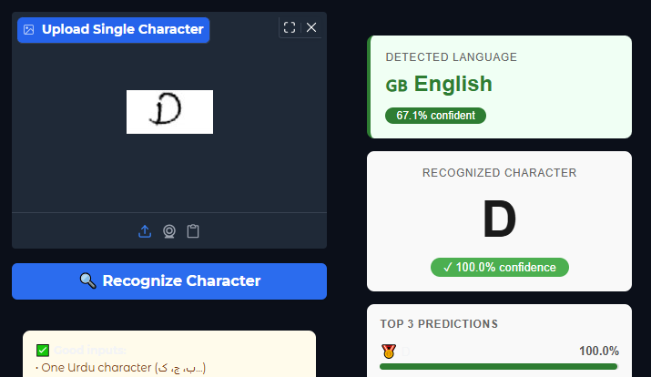
Figure 11.3: English character ‘P’ predicted at 99.8% confidence with Top 3 predictions shown
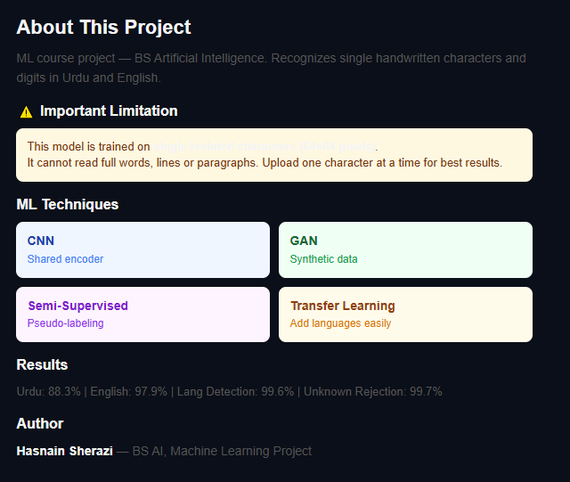
Figure 11.4: About tab showing all 4 performance metrics and ML techniques used

Chapter 12 Conclusion and Future Work

12.1 Conclusion
This project successfully developed and deployed a multilingual handwriting recognition system that addresses the challenging problem of Urdu and English character recognition under limited labeled data conditions. The key contributions of this work are:
- A shared encoder CNN architecture that enables incremental language addition without full retraining
- A Conditional GAN trained to generate realistic per-class synthetic Urdu and English character images
- A semi-supervised training framework with pseudo-labeling that improves accuracy significantly without additional labeled data
- An explicit 3-class language detector (Urdu/English/Unknown) that achieves 99.60% detection accuracy
- A live web application deployed on Hugging Face Spaces demonstrating real-world usability

Final Results Summary
Urdu: 88.31% | English: 97.91% | Lang Detection: 99.60% | Unknown Rejection: 99.67%
Training: 50 epochs | Dataset: 582,089 images | Model: 1.42M params

12.2 Future Work
Several directions can extend this work:
- Word and line recognition: Implement a CTC-based sequence model (CRNN or Transformer) to recognize full Urdu and English words and lines, not just isolated characters
- Additional languages: Add Arabic, Persian, and Hindi using the incremental learning mechanism already built into the architecture — each requiring only a new classification head
- Calibration: Apply temperature scaling to calibrate confidence scores and reduce model overconfidence on edge cases
- Mobile deployment: Convert the model to TensorFlow Lite or ONNX format for on-device inference on mobile phones
- Real-time recognition: Build a camera-based interface for real-time single-character recognition
- Larger architecture: Investigate MobileNetV3 or EfficientNet as the shared encoder backbone to improve accuracy while maintaining a small model size

References
[1] Goodfellow, I., Pouget-Abadie, J., Mirza, M., Xu, B., Warde-Farley, D., Ozair, S., ... & Bengio, Y. (2014). Generative adversarial nets. Advances in neural information processing systems, 27.
[2] Mirza, M., & Osindero, S. (2014). Conditional generative adversarial nets. arXiv preprint arXiv:1411.1784.
[3] Lee, D. H. (2013). Pseudo-label: The simple and efficient semi-supervised learning method for deep neural networks. Workshop on challenges in representation learning, ICML, 3(2).
[4] Berthelot, D., Carlini, N., Goodfellow, I., Papernot, N., Oliver, A., & Raffel, C. A. (2019). MixMatch: A holistic approach to semi-supervised learning. Advances in neural information processing systems, 32.
[5] Ali, H., Specia, L., & Kell, D. B. (2020). UHaT: Urdu handwritten text dataset. Kaggle Dataset.
[6] Li, M., Lv, T., Chen, J., Cui, L., Lu, Y., Florencio, D., ... & Wei, F. (2021). TrOCR: Transformer-based optical character recognition with pre-trained models. arXiv preprint arXiv:2109.10282.
[7] Fogel, S., Averbuch-Elor, H., Cohen, S., Mazor, S., & Litman, R. (2020). ScrabbleGAN: Semi-supervised varying length handwritten text generation. In CVPR.
[8] Devlin, J., Chang, M. W., Lee, K., & Toutanova, K. (2019). BERT: Pre-training of deep bidirectional transformers for language understanding. NAACL.
[9] Kang, L., Rusinol, M., Fornés, A., Riba, P., & Villegas, M. (2020). Distilling content from style for handwritten word recognition. arXiv preprint arXiv:2005.06440.
[10] Hussain, S., Murtaza, G., & Naz, S. (2015). Urdu Nastalique text recognition: A review. IEEE Access.

Appendix A — Dataset Details
All datasets are publicly available on Kaggle and were accessed in May–June 2026:

Dataset | Kaggle URL | License
UHaT | kaggle.com/datasets/hazrat/uhat-urdu-handwritten-text-dataset | CC BY 4.0
Urdu 120K | kaggle.com/datasets/mhassansaboor/... | Not specified
English Chars | kaggle.com/datasets/dhruvildave/... | Unknown
A-Z CSV | kaggle.com/datasets/sachinpatel21/... | Unknown
Arabic (ahcd1) | kaggle.com/datasets/mloey1/ahcd1 | Unknown
Chinese Hanzi | kaggle.com/datasets/pascalbliem/... | Unknown
Hindi | kaggle.com/datasets/suvooo/... | Unknown

Appendix B — Complete Hyperparameter Table
Component | Parameter | Value
Preprocessing | Image size | 64×64 pixels
Preprocessing | Normalization | Mean=0.5, Std=0.5
Preprocessing | Max per class | 2,000 images
CNN Encoder | Feature dimension | 256
CNN Encoder | Total parameters | 1.24M
GAN | Noise dimension | 100
GAN | Label embedding | 50-dim
GAN | Learning rate | 0.0002
GAN | Optimizer | Adam (β₁=0.5, β₂=0.999)
GAN | Epochs | 30
Training | Learning rate | 1e-3
Training | Optimizer | AdamW
Training | Weight decay | 1e-4
Training | LR schedule | Cosine Annealing
Training | Batch size | 64
Training | Total epochs | 50 (30 sup + 20 SSL)
SSL | Pseudo-label threshold | 0.90
SSL | Language loss weight | 0.4
SSL | Synthetic loss weight | 0.5
SSL | Gradient clip norm | 1.0

